SCREENSHOTS FOR MY CLASS WORK BASED ON ARITHMETIC OPERATORS

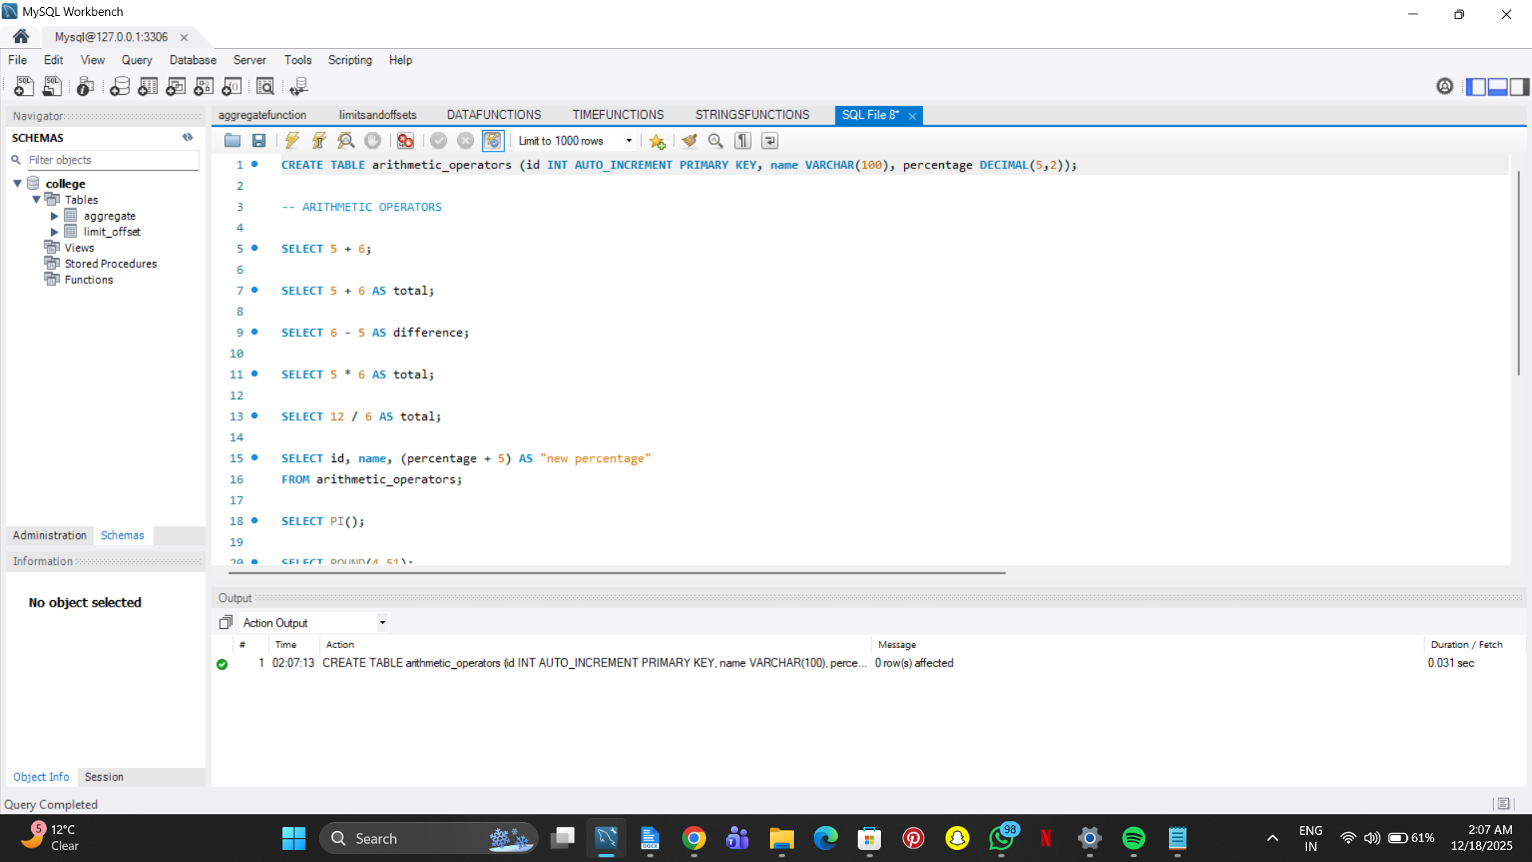

SELECT 5 + 6;

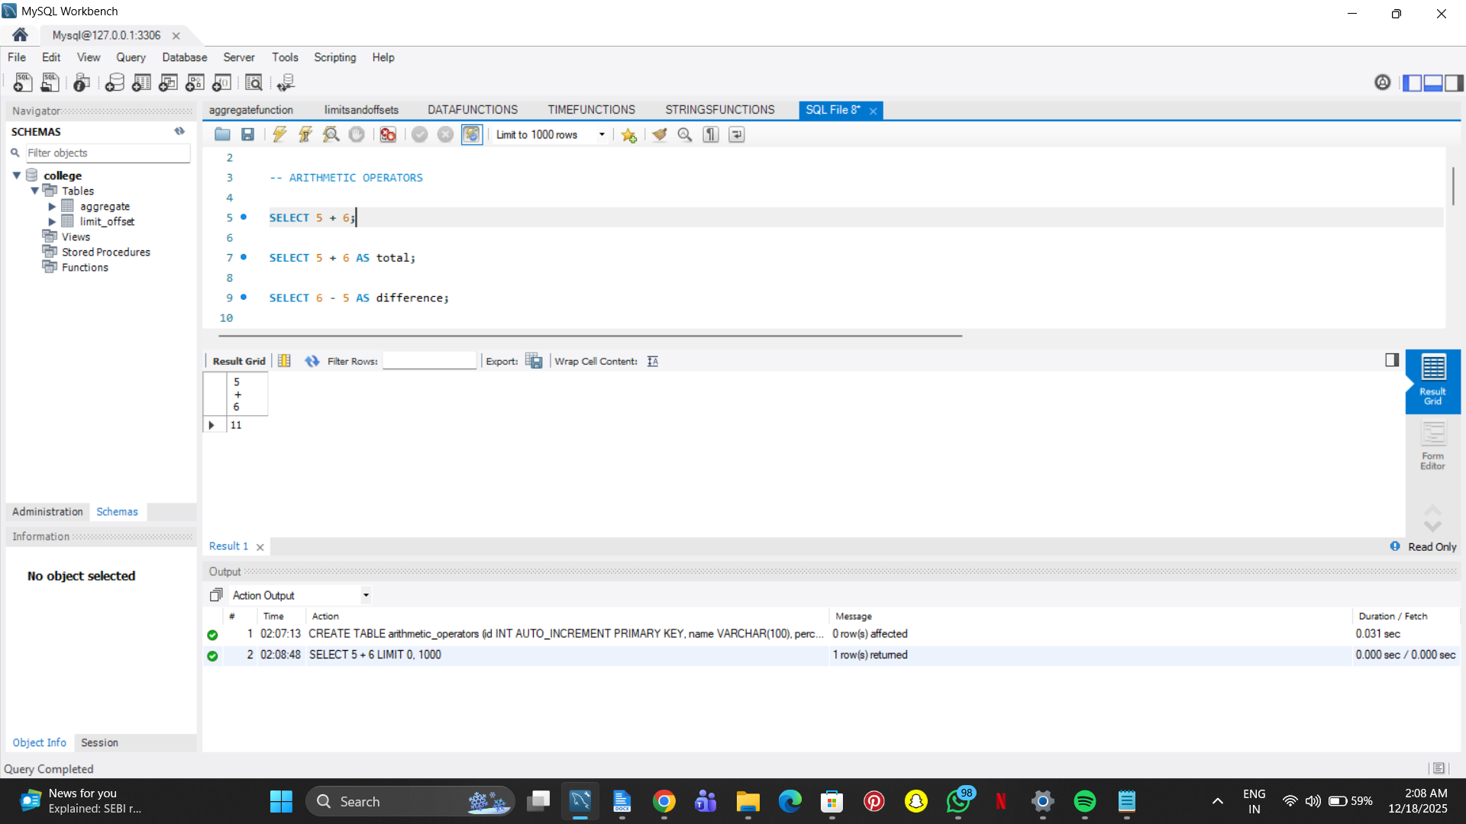

SELECT 5 + 6 AS total;

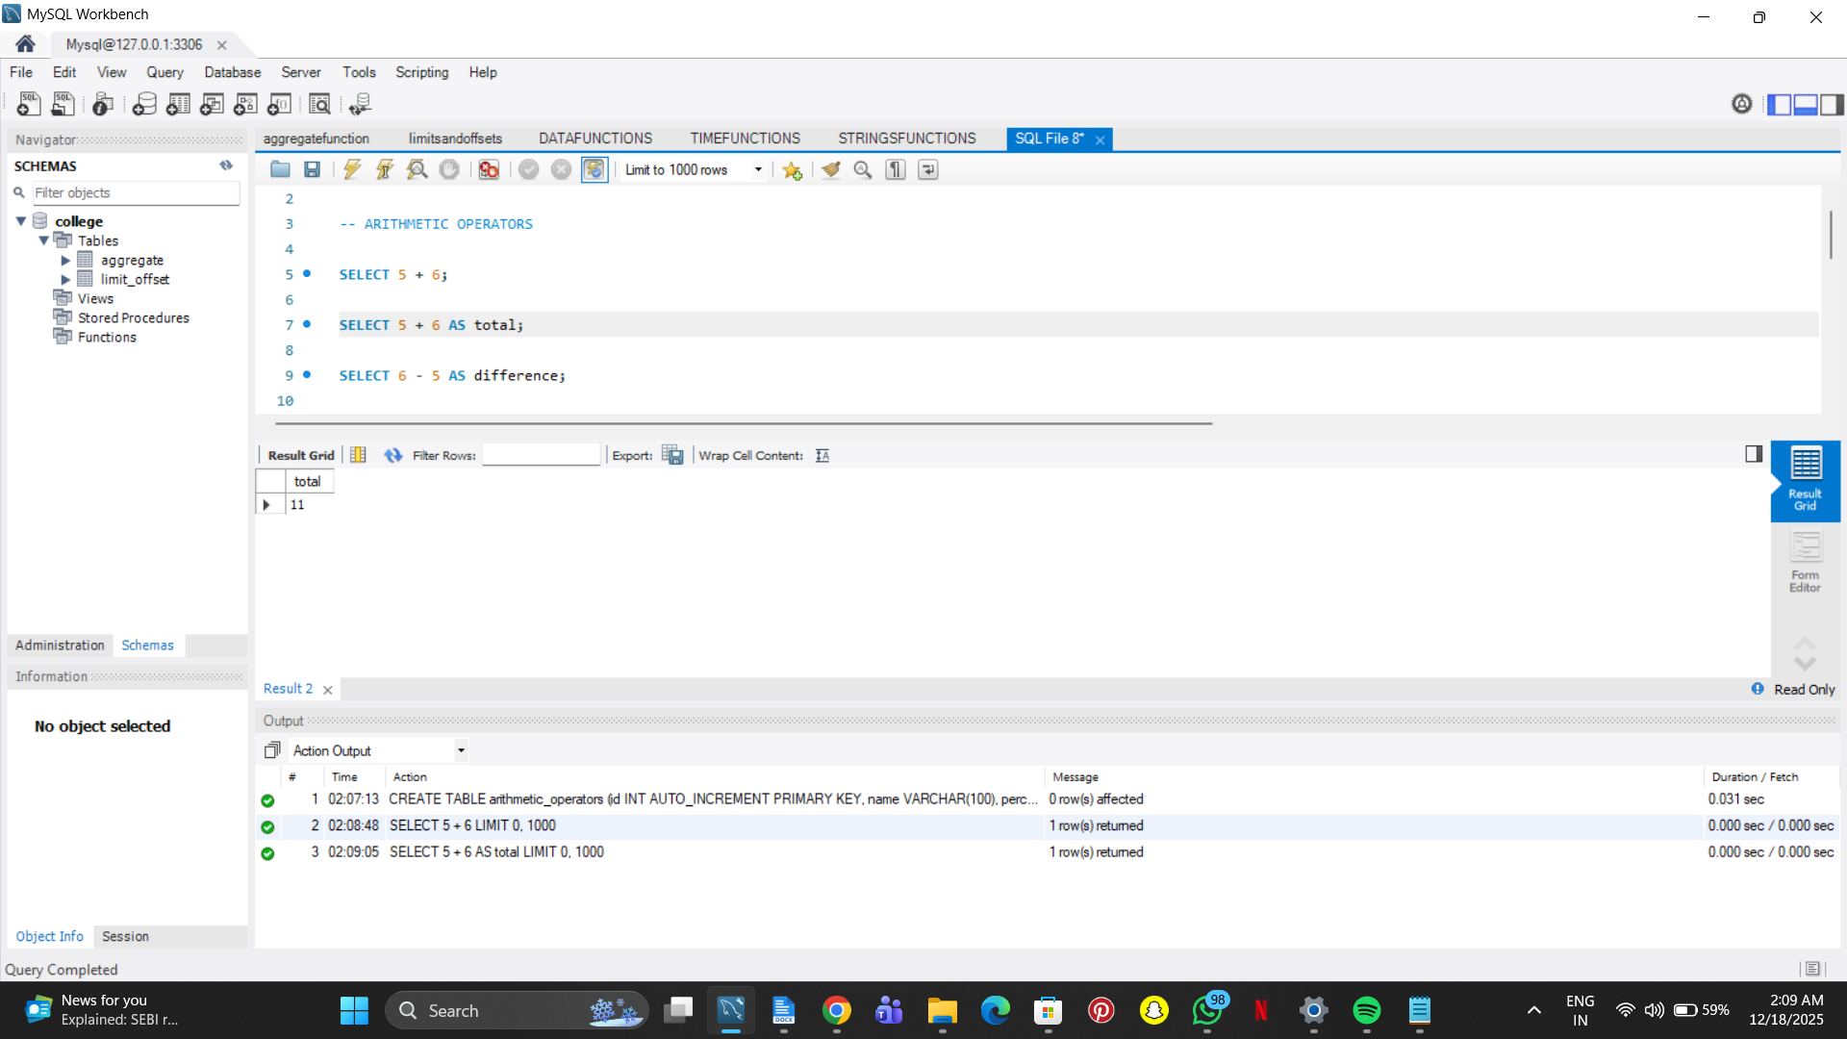

SELECT 6 - 5 AS difference;

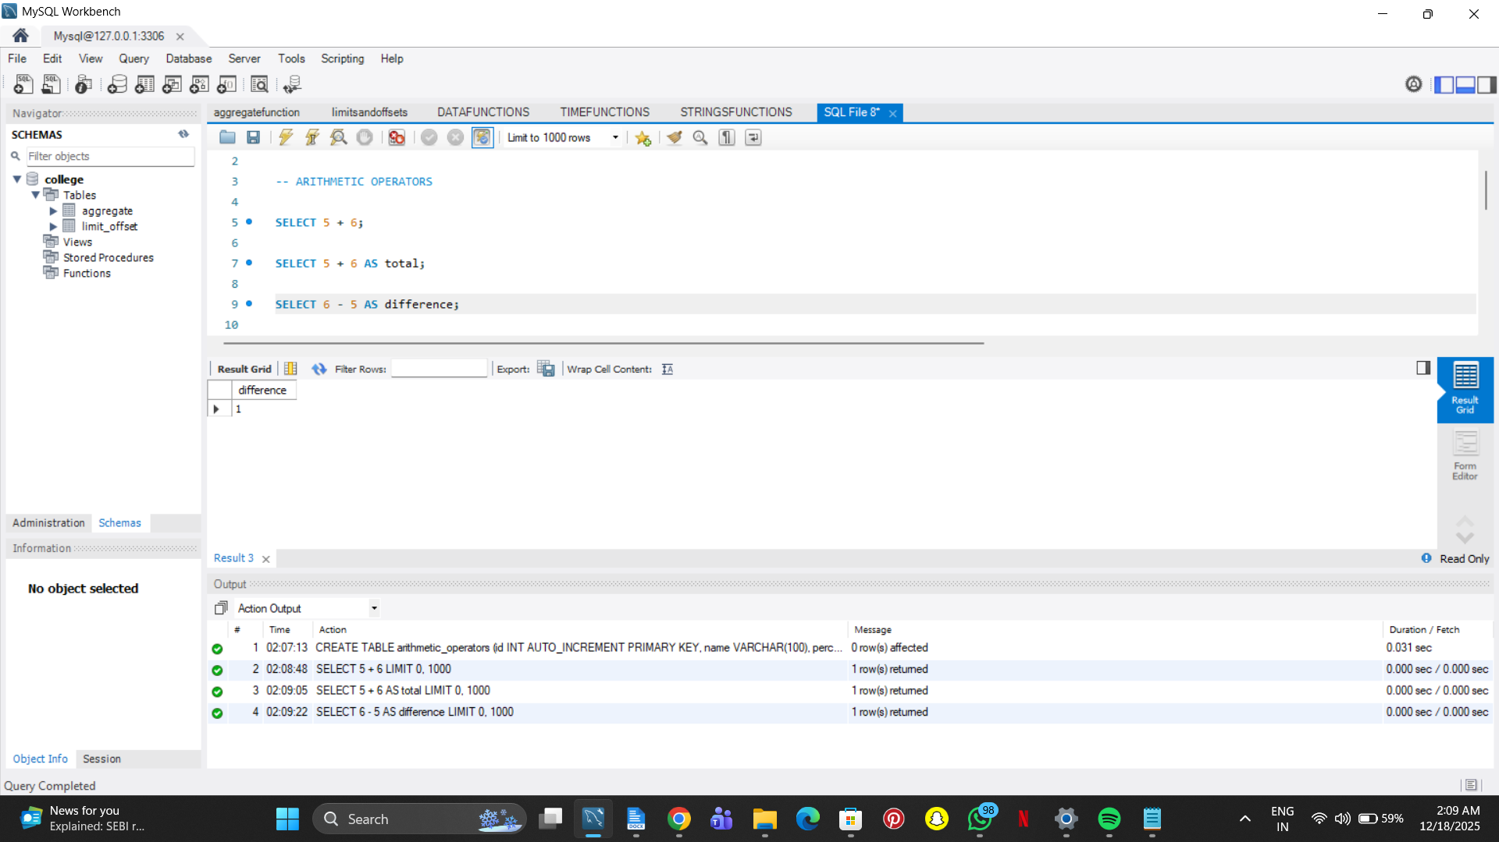

SELECT 5 * 6 AS total;

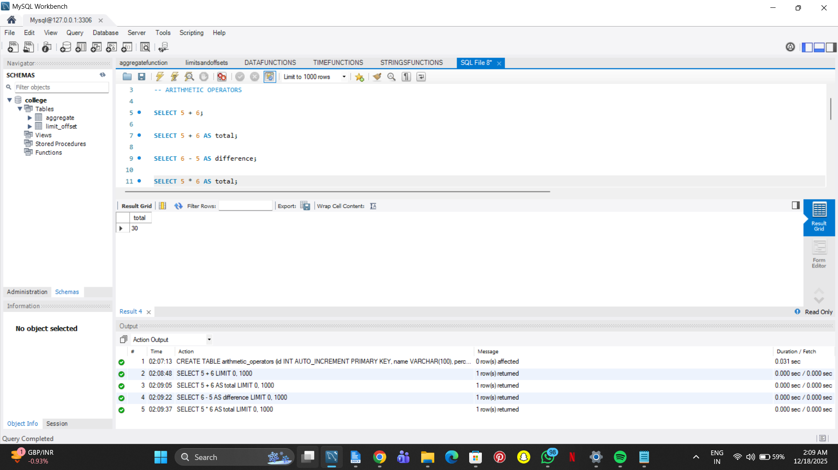

SELECT 12 / 6 AS total;

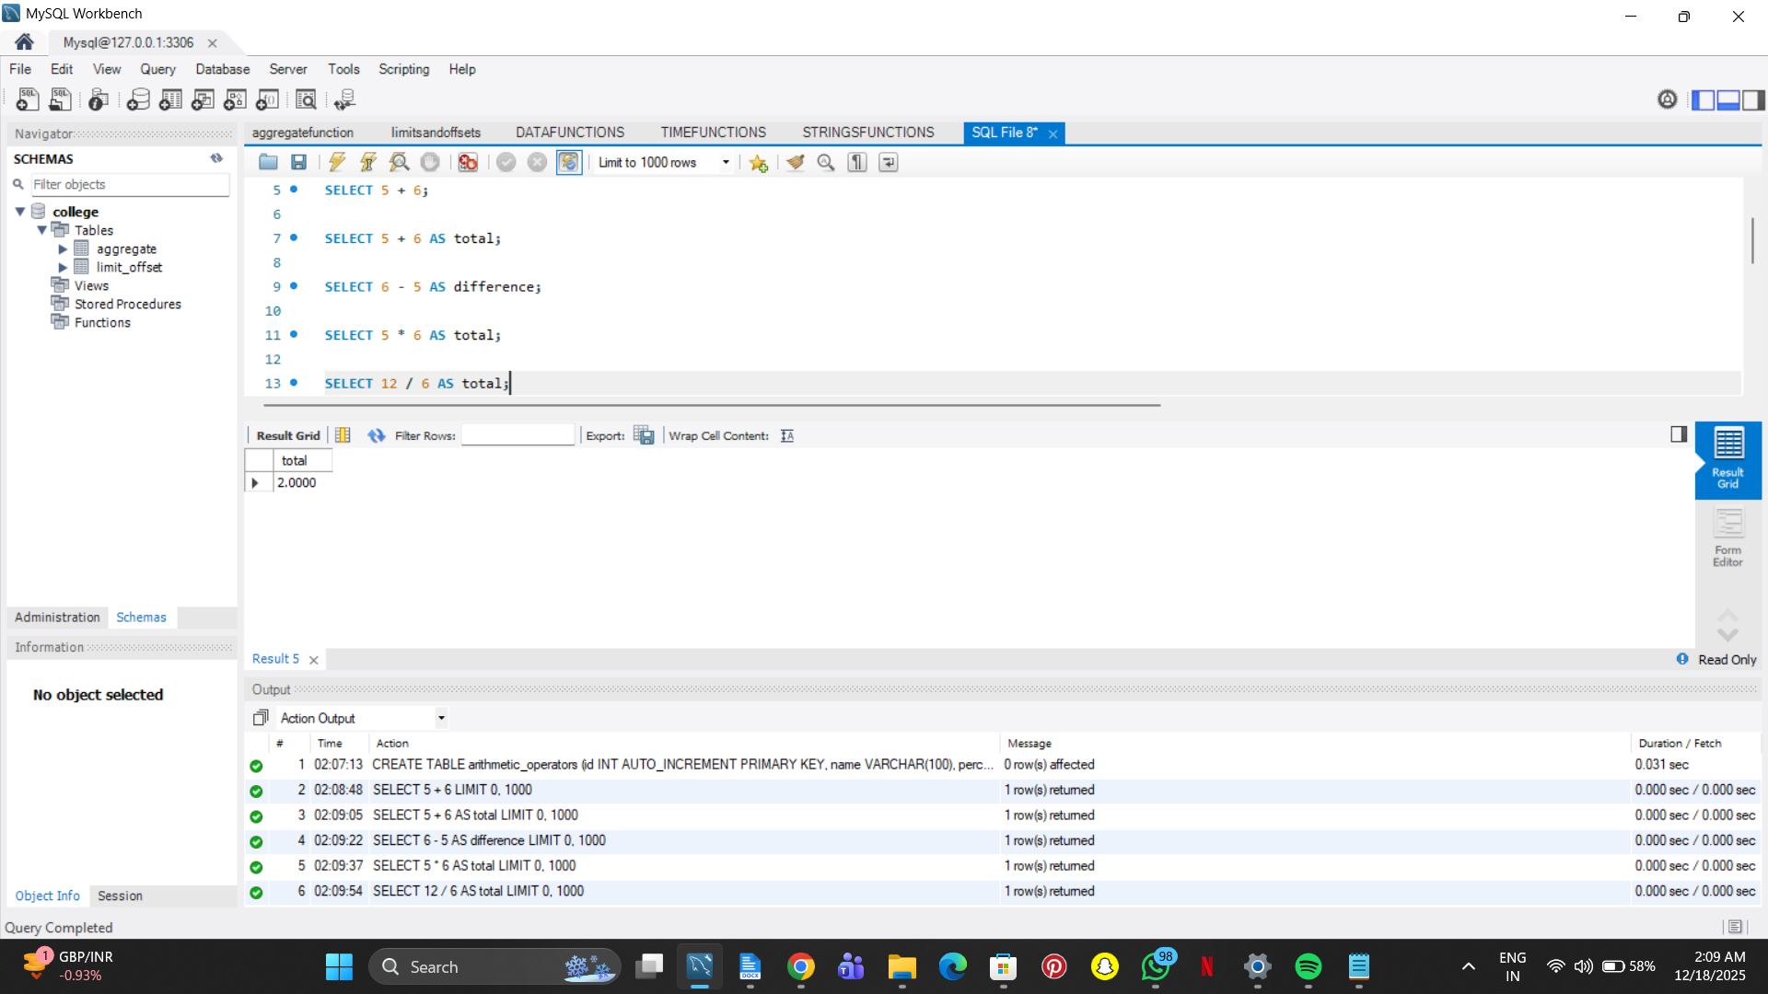

SELECT id, name, (percentage + 5) AS "new percentage"

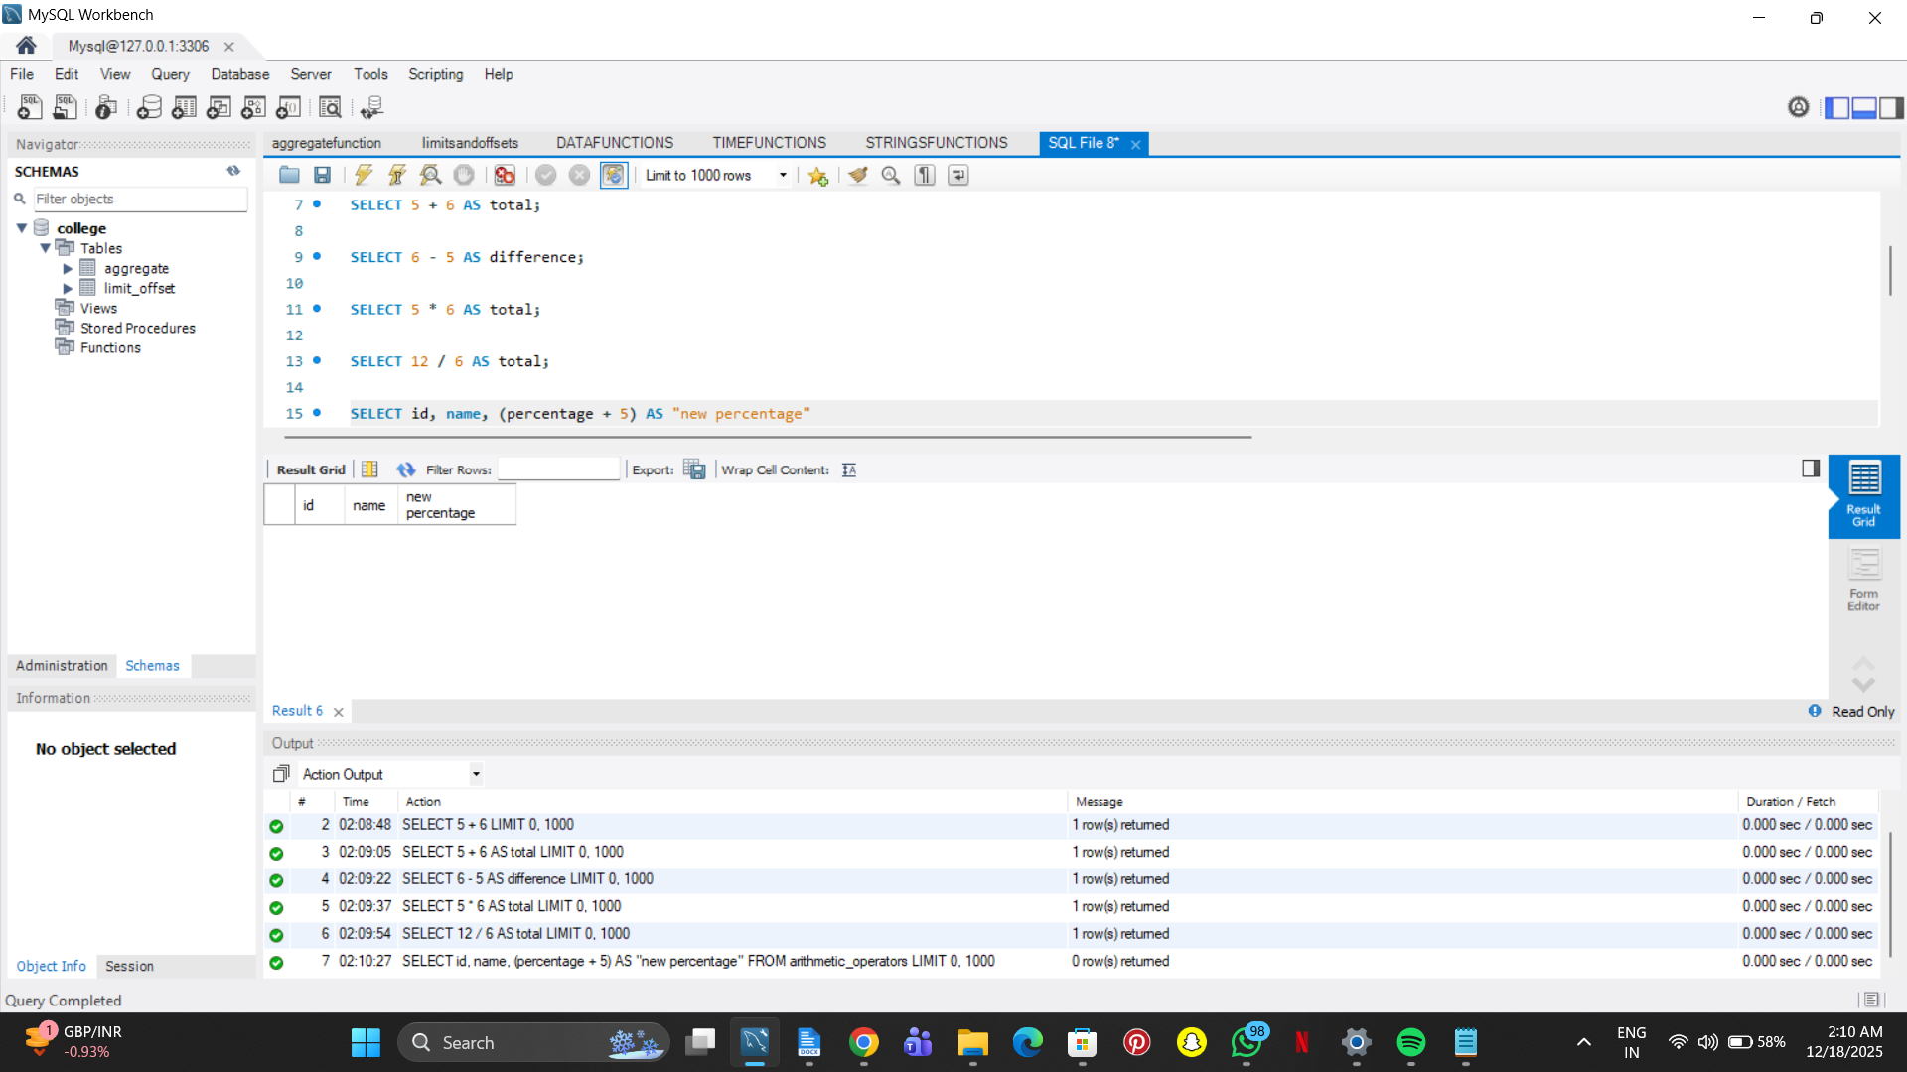

FROM arithmetic_operators;

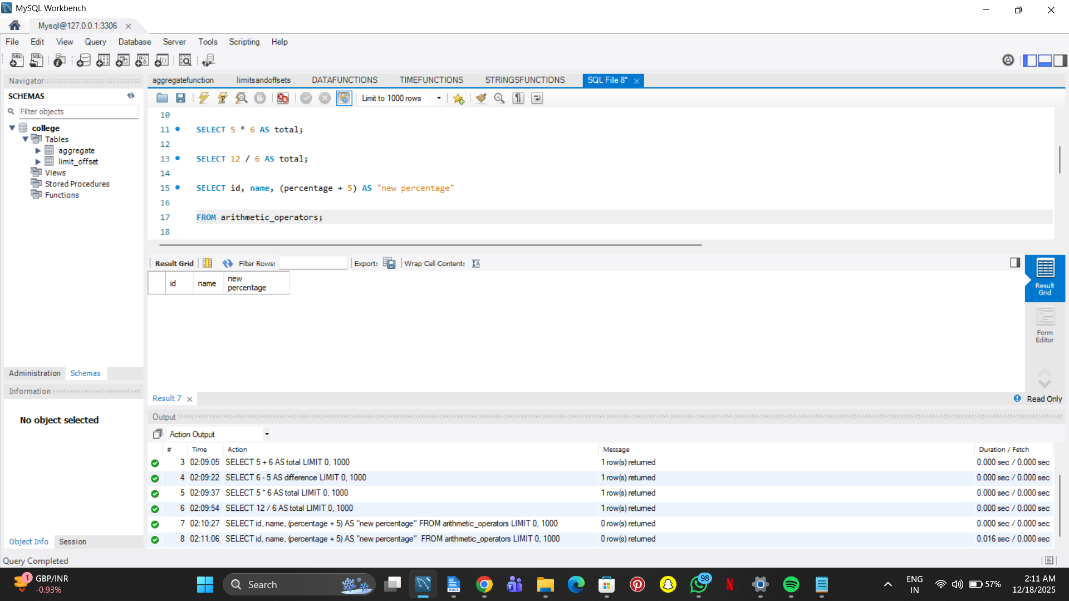

SELECT PI();

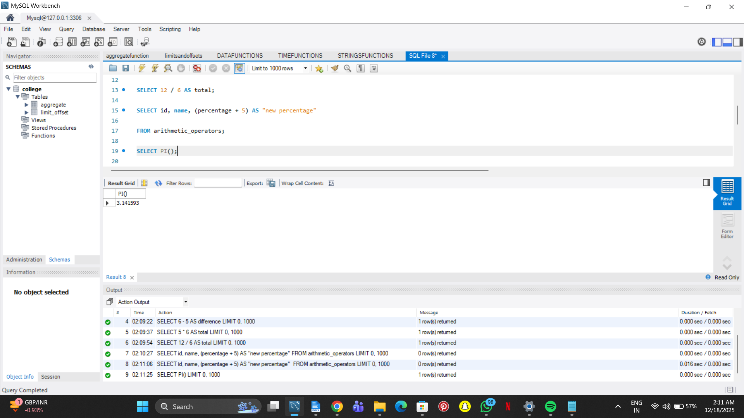

SELECT ROUND(4.51);

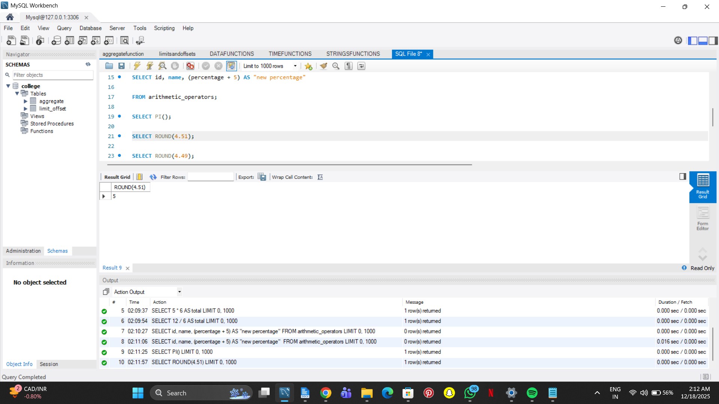

SELECT ROUND(4.49);

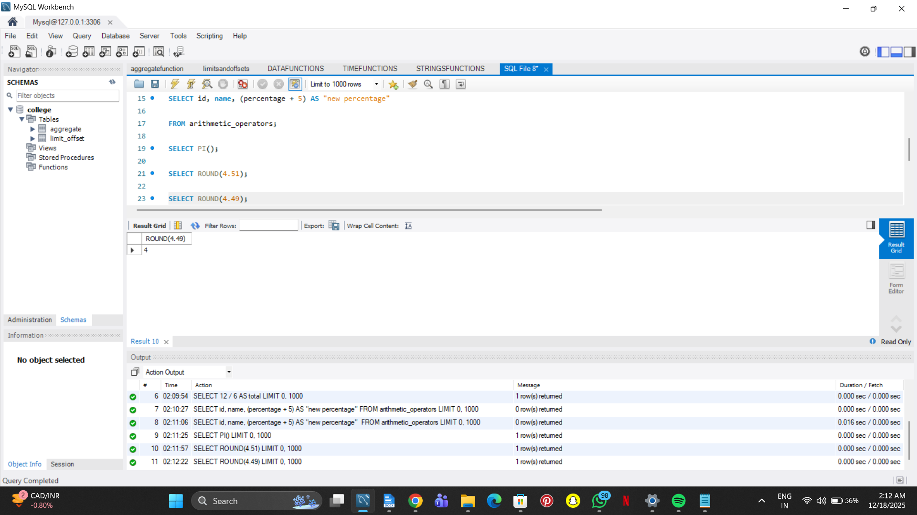

SELECT ROUND(-4.49);

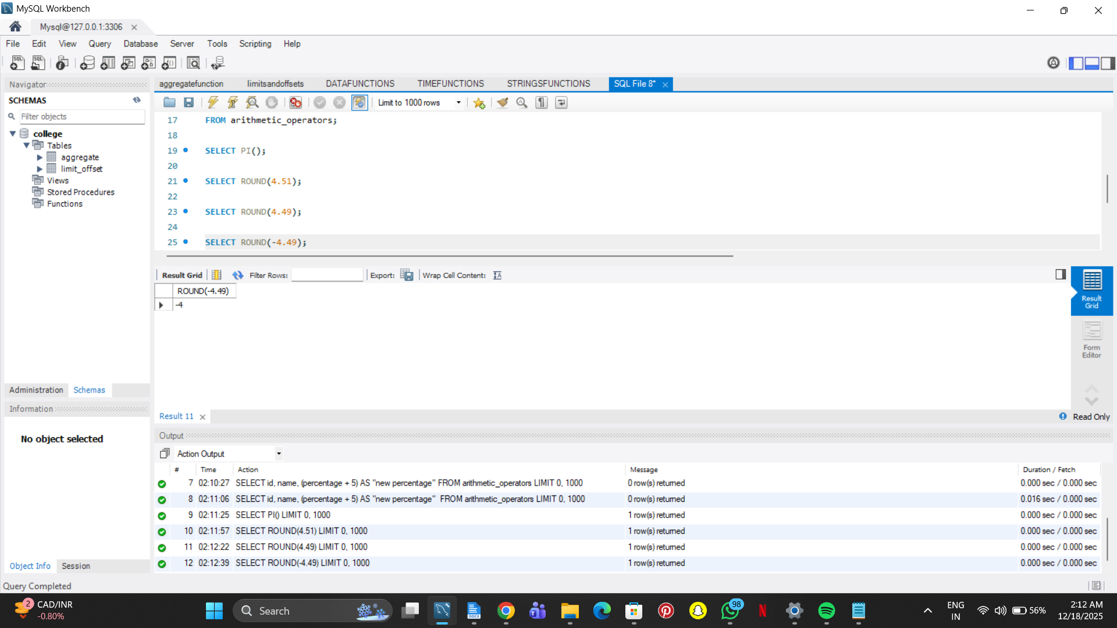

SELECT ROUND(1234.987, 1);

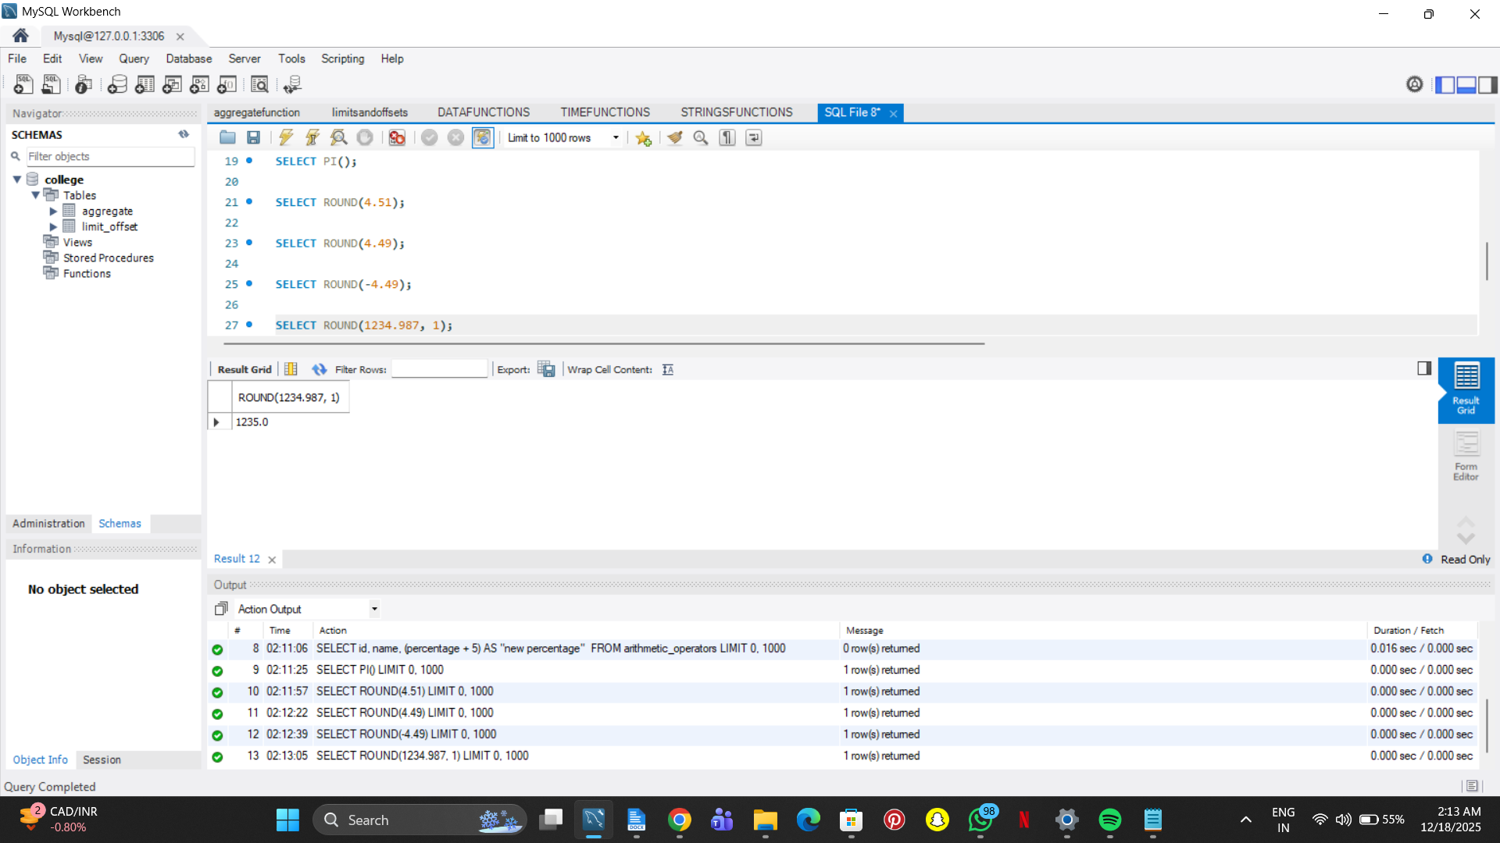

SELECT CEIL(1.23);

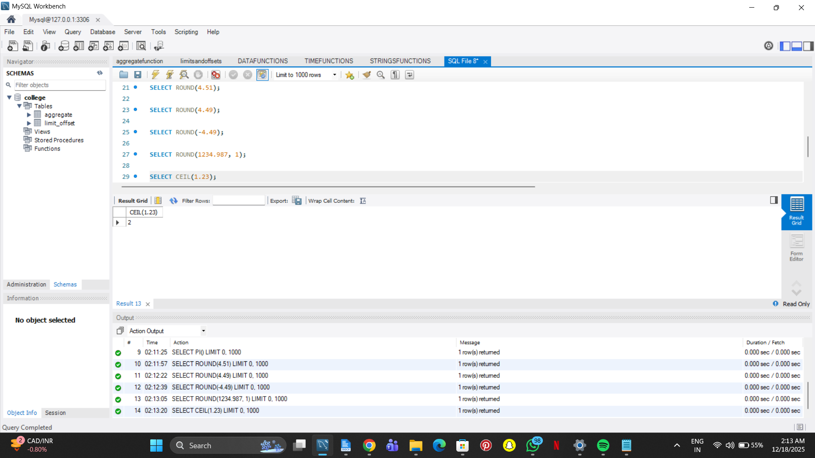

SELECT FLOOR(1.23);

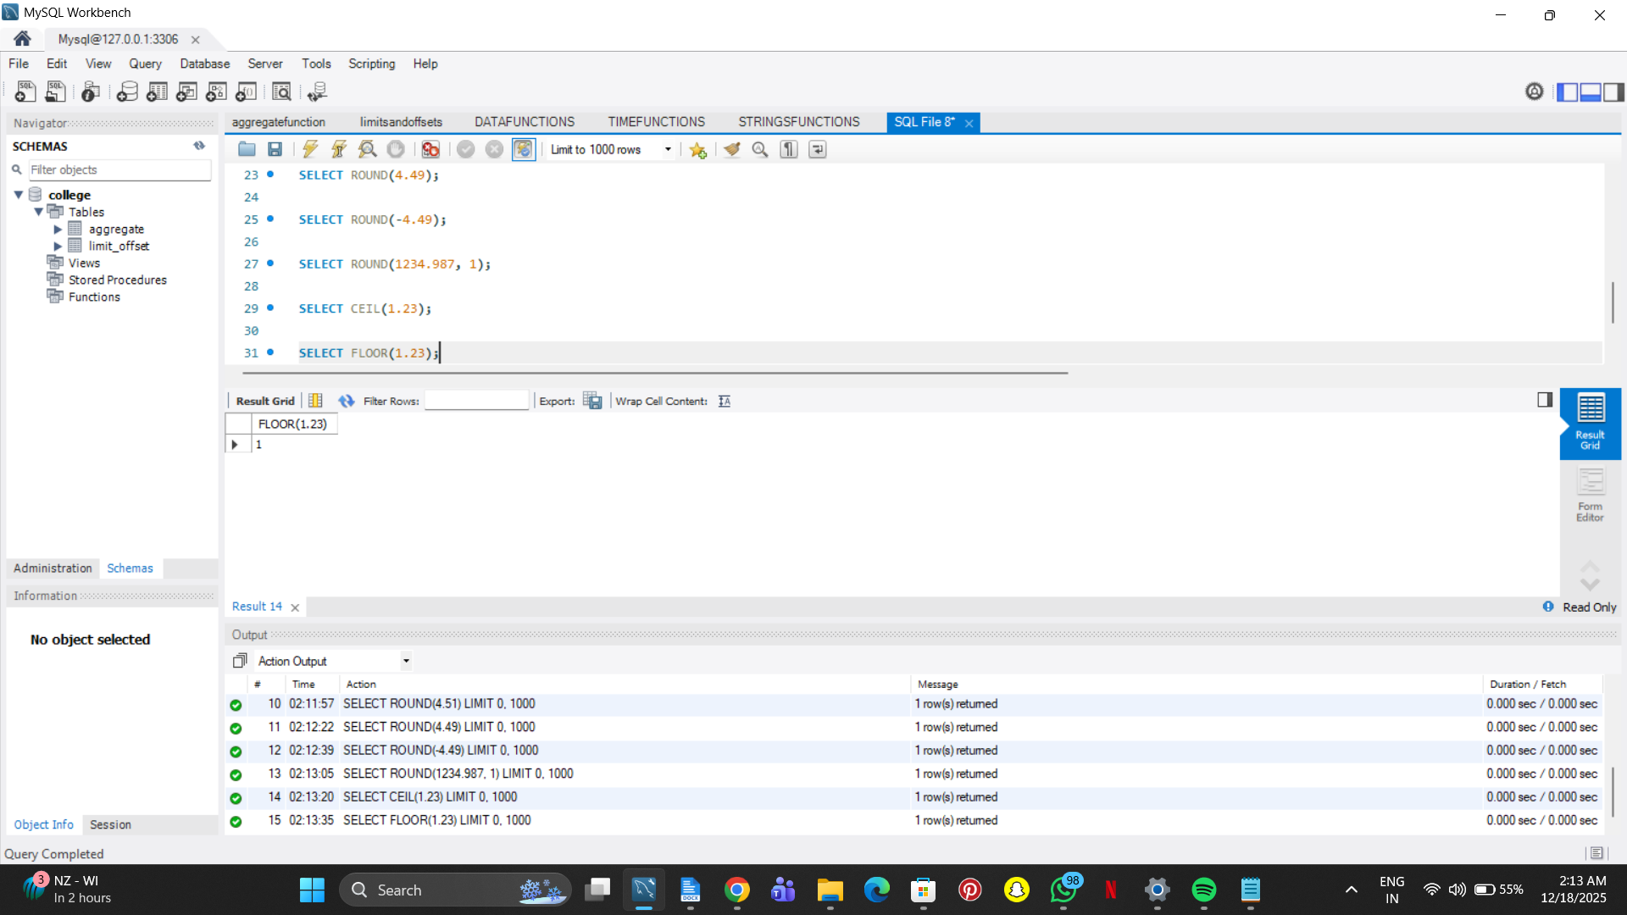

SELECT POW(2, 2);

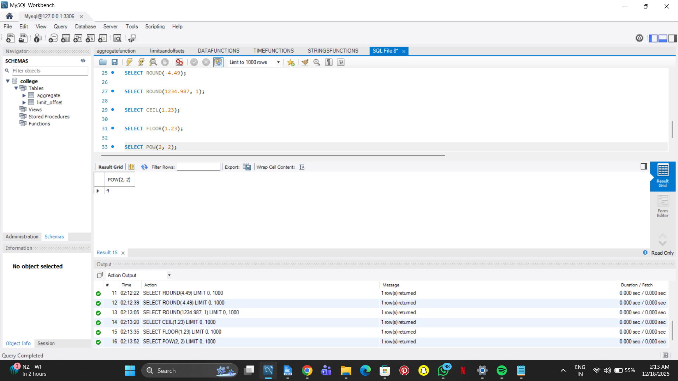

SELECT POW(2, 3);

